Create Azure Resource WalkThrough

## Task 1: Create a virtual machine

In this task, you’ll create a virtual machine using the Azure portal.

1. Sign in to the [Azure portal](https://portal.azure.com/learn.docs.microsoft.com).
2. Select Create a resource > Compute > Virtual Machine > Create.
3. The Create a virtual machine pane opens to the basics tab.
4. Verify or enter the following values for each setting. If a setting isn’t specified, leave the default value.

**Basics tab**

| **Setting** | **Value** |
| --- | --- |
| Subscription | Select Your Subscription |
| Resource group | Click Create New🡪Enter Name for your Resource group🡪OK name that begins with **learn**. |
| Virtual machine name | my-VM |
| Region | Leave default |
| Availability options | Leave default |
| Security type | Leave default |
| Image | Leave default |
| VM architecture | Leave default |
| Run with Azure Spot discount | Unchecked |
| Size | Leave default |
| Authentication type | Password |
| Username | azureuser |
| Password | Enter a custom password |
| Confirm password | Reenter the custom password |
| Public inbound ports | None |

1. Select Review and Create.
2. Select Create

## Task2: Verify resources created

Once the deployment is created, you can verify that Azure created not only a VM, but all of the associated resources the VM needs.

1. Select Home
2. Select Resource groups
3. Select your resource group name

You should see a list of resources in the resource group

**Task 3:Clean up the Resources**

1. Select all the resource in Resource Group
2. Click on Delete resource group

1. Enter resource group name to confirm deletion
2. Click Delete

Lab 1: **Create Virtual Network and Subnet**

1. **Create Virtual Network (By default namespace is 10.0.0.0/16)**

Search 🡪 Virtual network 🡪 +Create 🡪

1. **Next 🡪 Next 🡪** Observe the default address range and default subnet.
2. **Review + Create** 🡪 **Create.**

**Add one more subnet.**

1. **Select DemoVnet** 🡺 **Subnets** 🡪 **+ Subnet**

**Name = FrontEnd**

1. **Select DemoVnet 🡪 Diagram (Under Monitoring)**

**Lab2: Create Network Security Group (NSG) and associate with FrontEnd Subnet**

1. Create **NSG** for Frontend

Search 🡪 Network Security Groups 🡪 + Create

**🡪 Review + Create**

1. **Associate the NSG to the FrontEnd subnet**

DemoVnet 🡪 Settings 🡪 Subnets 🡪 FrontEnd 🡪

Network security group = **FrontEnd-Nsg**

🡪**Save**

**Lab3: Create Virtual Machine in FrontEnd Subnet and connect to VM**

Browse 🡪 Virtual Machine 🡪 +Create 🡪 Azure Virtual Machine 🡪

**Next 🡪 Accept all defaults in Disks tab 🡪 Next**

**Go to Networking Tab 🡪**

**Select the options as show below**

**Review + Create 🡪 Create**

**Lab4: Connect to Virtual machine using RDP and Configure Inbound rule for FrontEnd-Nsg**

**FOR MT BANK: Please use AWS Workspace for RDP**

1. Go to AWS Workspace 🡪 Open <https://portal.azure.com> 🡪 Search Virtual Machines 🡪 Select VM
2. VM1🡪 Connect 🡪 Download RDP File 🡪 Open the file 🡪 Observe that connection is failed.
3. Configure Security rules for Frontend-Nsg

Select Frontend-nsg 🡪 Settings 🡪 **Inbound security rules 🡪 +Add**

**🡪 Save**

1. Try now to connect to Virtual Machine using RDP again and it will be successful.

**Lab5: Install IIS on Virtual machine and allow http traffic to VM**

1. Connect to VM 🡪 Server Manager 🡪Dashboard 🡪 Add roles and features 🡪 Next 🡪 Next 🡪 Next 🡪Select **Web Server (IIS)** 🡪 Add Feature🡪Next 🡪 Next 🡪 Next🡪Next🡪Install.
2. Azure Portal 🡪 Select Virtual Machine 🡪 Networking 🡪 **Add Inbound Rule** 🡪

Configure Rule to allow http to VM.

🡪 Add

1. Select VM 🡪 Overview 🡪 Note the Public IP address
2. In Browser 🡪 visit http://<PublicIPAddressOfVM>
3. Note that you get the default page of the website.

**Lab6: Create Container Instance**

1. Search 🡪 Container instance 🡪 +Create 🡪

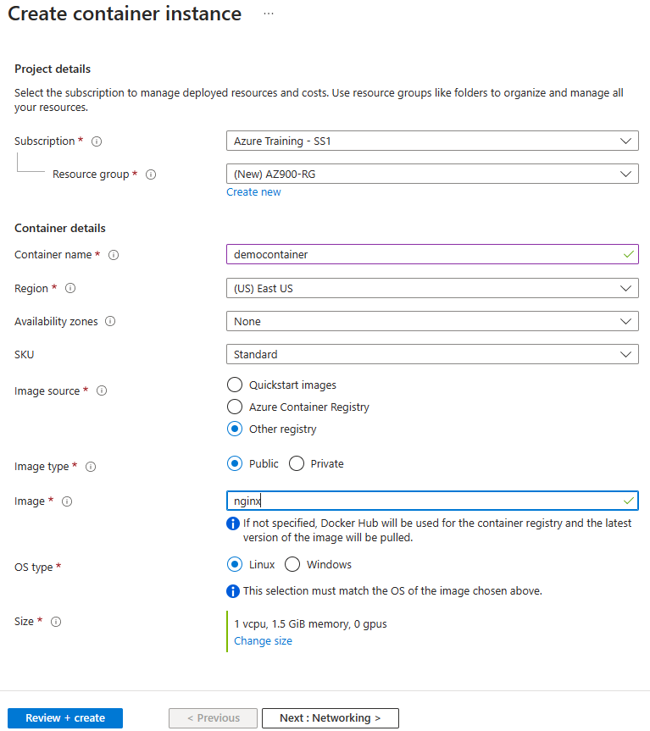

🡪 Review + create 🡪 Create.

1. Copy IP address of Container Instance
2. In Browser 🡪 visit http://<PublicIPAddressOfVM>
3. Note that you get the default page of the website.

Lab7: Create Azure Function

1. Create Function app

Browse Function app🡪+Create🡪

Review+Create🡪Create

1. Add Azure function to it

Dssdemofunapp 🡪 Overview🡪Functions 🡪 Create in Azure portal🡪+Create

🡪Create

1. Invoke Azure Function

Dssdemofunapp🡪Overview🡪 Functions🡪HttpTrigger1🡪 Get Function Url🡪Copy it

1. Paste in browser 🡪 Add Querystring to Copied URL: https://<Copied Url>&name=John

**Lab8: Create Web App using Docker image**

Search 🡪 App services 🡪 + Create 🡪 +Web app

Note: In the image below: Please replace vandemo with yourname as that is used for the website name.

**Docker Tab**

**Open the Website in browser:**

Select the App Service 🡪 Overview 🡪 Default domain:

<https://vandemo.azurewebsites.net>

**Lab9: Create a storage account, Create public Container upload data and access it using url.**

Create Storage Account

1. Search **Storage account** 🡪 +Create

1. **Advanced Tab:**

1. Review 🡪 Create

**Create Container and Upload a file:**

1. Select Storage Account 🡪 Data Storage 🡪 Container 🡪 +Container 🡪

1. Create
2. Select **public-images** container 🡪 Upload 🡪 Browse and upload a file

1. 🡪 Upload

Access the blob using url

1. Select uploaded **Blob** 🡪 Copy URL and paste in browser.

1. **To Download the file: Copy and paste the URL in browser**

**Lab10: Use Pricing Calculator**

Refer:

<https://azure.microsoft.com/en-us/pricing/calculator/>

**Lab11: Use TCO Calculator**

1. Go to <https://azure.microsoft.com/en-us/pricing/tco/calculator/>
2. Under **Define your workloads**, select **Add server workload** to create a row for your bank of Windows Server VMs.
3. Under **Servers**, set the value for each of these settings:

|  |  |
| --- | --- |
| **Setting** | **Value** |
| Name | **Servers: Windows VMs** |
| Workload | **Windows/Linux Server** |
| Environment | **Virtual Machines** |
| Operating system | **Windows** |
| Operating System License | **Datacenter** |
| VMs | **50** |
| Virtualization | **Hyper-V** |
| Core(s) | **8** |
| RAM (GB) | **16** |
| Optimize by | **CPU** |
| Windows Server 2008/2008 R2 | **Off** |

1. Select **Add server workload** to create a second row for your bank of Linux VMs. Then specify these settings:

|  |  |
| --- | --- |
| **Setting** | **Value** |
| Name | **Servers: Linux VMs** |
| Workload | **Windows/Linux Server** |
| Environment | **Virtual Machines** |
| Operating system | **Linux** |
| VMs | **50** |
| Virtualization | **VMware** |
| Core(s) | **8** |
| RAM (GB) | **16** |
| Optimize by | **CPU** |

1. Under **Storage**, select **Add storage**. Then specify these settings:

|  |  |
| --- | --- |
| **Setting** | **Value** |
| Name | **Server Storage** |
| Storage type | **Local Disk/SAN** |
| Disk type | **HDD** |
| Capacity | **60 TB** |
| Backup | **120 TB** |
| Archive | 1. **TB** |

1. Under **Networking**, set **Outbound bandwidth** to **15 TB**.
2. Select **Next**.

**Adjust assumptions**

Here, you specify your currency. For brevity, you leave the remaining fields at their default values.

In practice, you would adjust any cost assumptions and make any adjustments to match your current on-premises environment.

1. At the top of the page, select your currency. This example uses **US Dollar ($)**.
2. Select **Next**.

**View the report**

Take a moment to review the generated report.

Remember, you've been tasked to investigate cost savings for your European datacenter over the next three years.

To make these adjustments:

1. Set **Timeframe** to **3 Years**.
2. Set **Region** to **East US**.

**Lab12: Create Azure Policy to allow resource creation only in particular region**

## Policy 🡪 Definitions 🡪 Filter: Search = Location 🡪 Select Allowed locations

1. Review the Definition and click on **Assign** (in top)
2. Basics Tab:
   1. Scope = <your subscription>
   2. Next
3. Advanced Tab: No changes
4. Parameters Tab 🡪 Allowed Locations: Select East US and East US2

1. Remediation: No changes
2. Non-compliance messages: Non-compliance message = This location not allowed
3. Review + Create 🡪 Create
4. Try creating a storage account in any other region and note the error…

**Lab13: Create Resource Lock for Storage Account**

Refer:

<https://docs.microsoft.com/learn/modules/describe-features-tools-azure-for-governance-compliance/5-exercise-configure-resource-lock>